**Department of Electronics and Communication Central University of Rajasthan, Ajmer**



Signal and System Lab

Subject ...................................................................................................

ECE 214

Subject Code ...................................................................................................

3

111

Experiment No. .......................................................................................

Date:- - -2024

Roll no:- 2022BTECE012

Name:- Ojasvee Satija

**Title: -** To Make the Password Verification Code using MATLAB

**Apparatus required:** - Downloaded MATLAB or OCTAVE software in device.

**Introduction:**- According to this code when the user input the accurate credentials then only he/she gets the entry into the software or any of the program.

**Code:-**

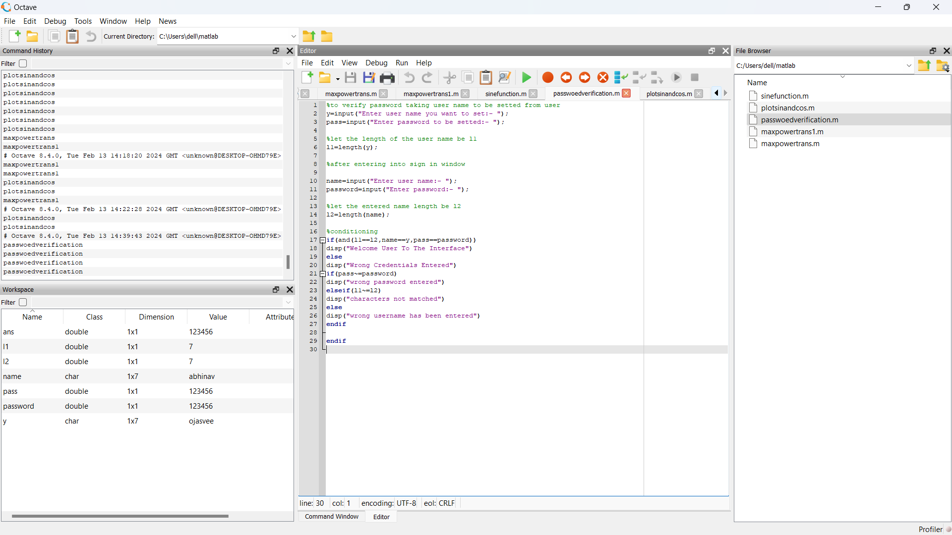

**Entered input and related outputs:-**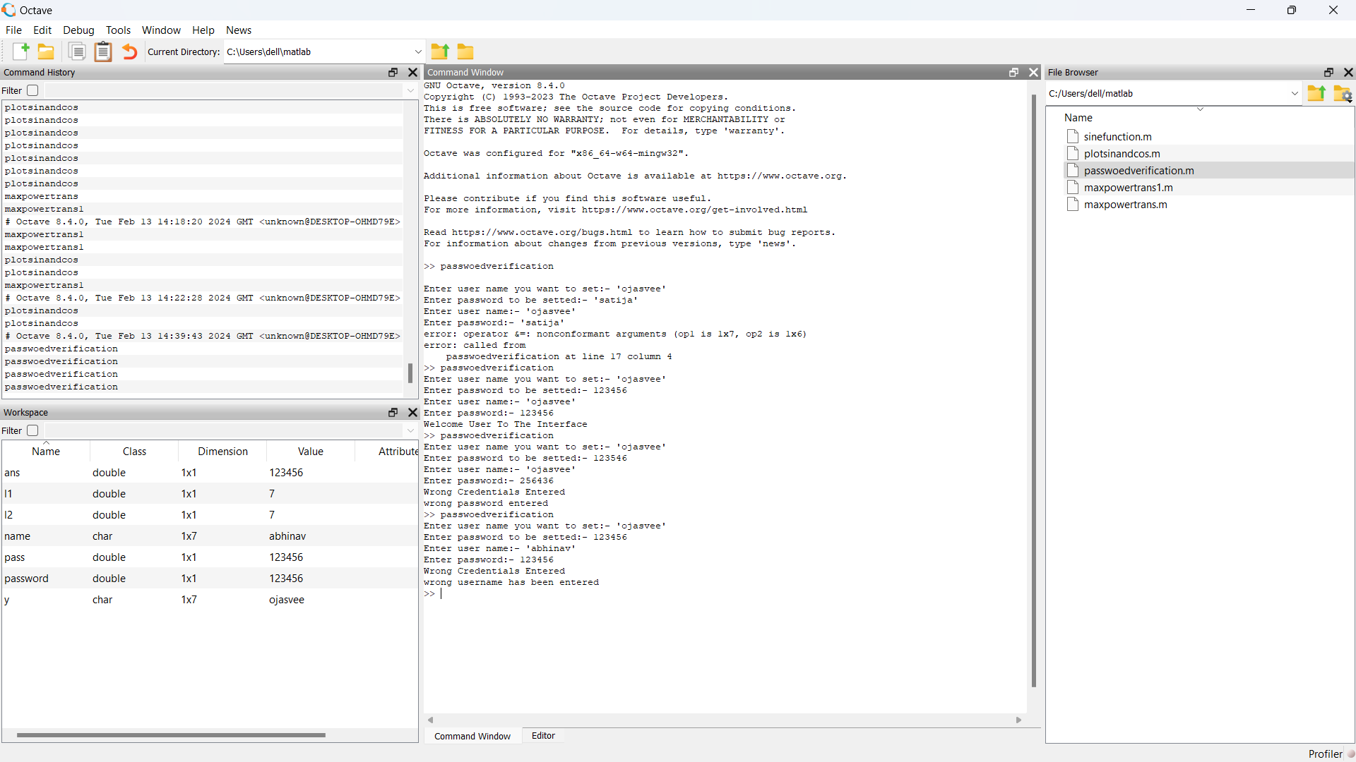

**Result:-** Completed the password verification code in GUI Octave